FINDING TIME COMPLEXITY OF ALGORITHMS

Finding Complexity using Counter Method
PROBLEM 1:

Convert the following algorithm into a program and find its time complexity using the counter method.
void function (int n)
{
int i= 1;
int s =1;
while(s <= n)
{
i++;
s += i;
}
}
Note: No need of counter increment for declarations and scanf() and count variable printf() statements.
Input:
A positive Integer n
Output:
Print the value of the counter variable

For example:
Input | Result
9 | 12
Answer:
#include <stdio.h>

int main()
{
int n, i = 1, s = 1, count = 0;

scanf("%d", &n);

count++;
count++;

while (s <= n)
{
count++;
i++;
count++;
s += i;
count++;
}

count++;

printf("%d", count);

return 0;
}
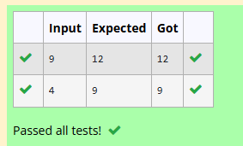

PROBLEM 2:
Convert the following algorithm into a program and find its time complexity using the counter method.
void func(int n)
{
if(n==1)
{
printf("*");
}
else
{
for(int i=1; i<=n; i++)
{
for(int j=1; j<=n; j++)
{
printf("*");
printf("*");
break;
}
}
}
}

Note: No need of counter increment for declarations and scanf() and count variable printf() statements.
Input:
A positive Integer n
Output:
Print the value of the counter variable

Answer:
#include <stdio.h>

int main(void)
{
int n;
int count = 0;
scanf("%d", &n);
count++;

if (n == 1)
{
count++;
}
else
{
int i;
count++;

for (i = 1; i <= n; i++)
{
count++;
int j;
count++;
for (j = 1; j <= n; j++)
{
count++;
count++;
count++;
break;
}
}
}
printf("%d", count);

return 0;
}
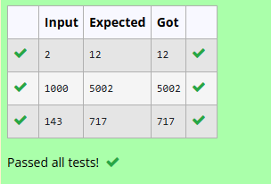

PROBLEM 3:
Convert the following algorithm into a program and find its time complexity using counter method.
Factor(num) {
{
for (i = 1; i <= num;++i)
{
if (num % i== 0)
{
printf("%d ", i);
}
}
}
Note: No need of counter increment for declarations and scanf() and counter variable printf() statement.
Input:
A positive Integer n
Output:
Print the value of the counter variable

Answer:
#include <stdio.h>

int main()
{
int num;
scanf("%d", &num);

int count = 0;
int i = 1;

while (1)
{
count++; // i <= num condition

if (i > num)
break;

if (num % i == 0)
{
count++; // printf("%d ", i)
}

i++;
count++; // ++i
}

printf("%d", count);

return 0;
}
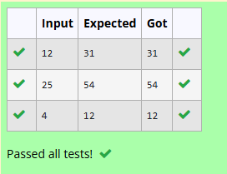

PROBLEM 4:
Convert the following algorithm into a program and find its time
complexity using counter method.
void function(int n)
{
int c= 0;
for(int i=n/2; i<n; i++)
for(int j=1; j<n; j = 2 * j)
for(int k=1; k<n; k = k * 2)
c++;
}
Note: No need of counter increment for declarations and scanf() and count variable printf() statements.
Input:
A positive Integer n
Output:
Print the value of the counter variable

Answer:
#include <stdio.h>

int main()
{
int n;
scanf("%d", &n);

int c = 0;

c++;

for (int i = n / 2; i < n; i++)
{
c++;

for (int j = 1; j < n; j = 2 * j)
{
c++;

for (int k = 1; k < n; k = k * 2)
{
c++;
c++;
}

c++;
}

c++;
}

c++;

printf("%d", c);

return 0;
}
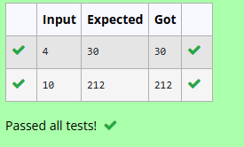

PROBLEM 5:
Convert the following algorithm into a program and find its time complexity using counter method.
void reverse(int n)
{
int rev = 0, remainder;
while (n != 0)
{
remainder = n % 10;
rev = rev * 10 + remainder;
n/= 10;
}
print(rev);
}
Note: No need of counter increment for declarations and scanf() and count variable printf() statements.
Input:
A positive Integer n
Output:
Print the value of the counter variable

Answer:
#include <stdio.h>

void reverse(int n)
{
int rev = 0, remainder;
int count = 0;

while (n != 0)
{
count++;
remainder = n % 10;

count++;
rev = rev * 10 + remainder;

count++;
n /= 10;

count++;
}

count += 3;
printf("%d", count);
}

int main()
{
int n;
scanf("%d", &n);

reverse(n);

return 0;
}
